First Grade Supply List
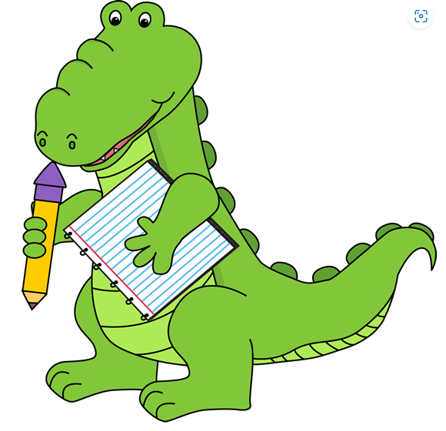
- $30.00 Class Fee – Check written to Alyce Taylor
- Twistable Crayola Crayons – 24 pack
- 1 dozen Pre-Sharpened Ticonderoga Pencils
- 1 Pencil Box
- 12 Glue sticks
- Dry erase Expo markers- 6-12 pack
- 6 Thin tip Black Expo Markers (no colors)
- Black sharpies- 2 pack
- 1 Skinny Yellow Highlighter

** Additionally, the following items are specific to your child’s class. Please look for your child’s teacher below to see what else is needed for their class! **

Mrs. Kirby  1 set of durable, comfy, wired headphones to keep in class (please label name)  Wish List:  White Elmers Glue  Duck Tape (all colors)  Scotch tape  AAA batteries  Colored Sharpies  Mr. Sketch Scented Markers  Kleenex  Brown paper lunch bags Small prize box toys | Mrs. Hackler  1 White Elmers Glue– Last name A-L  1 Container Baby Wipes – Last name J-Z  1 Fiskars Kids scissors  1 Prang Watercolors  Wish List:  Duck Tape– any color 16 ct. Crayola crayons Colored Sharpies  Crayola Markers | Mrs. Gustafson  Crayons – 24 pack  1- 3 ring 1" binder, with clear front pocket  Last name A-L-1 Gallon size bags  Last name M-Z-1 Sandwich size bags  1 box Kleenex  Wish List:  Smelly chap stick (for rewards)  Mr. Sketch scented markers  Fun band aids  snack pack goldfish  colored printer paper  FLAIR pens  hand sanitizer  AAAbatteries,  small prize box toys | Mrs. Rousseau  1 Container Clorox wipes  1 folder for homework (Your child can choose- please write first and last name)  1 pack Crayola colored pencils  1 box Kleenex  Wish List:  Any type of crafting/project-based materials

